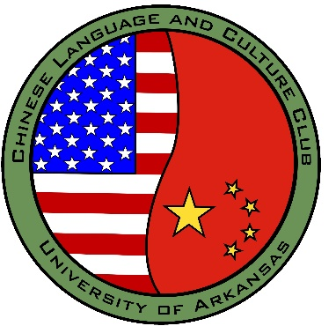

FOR MORE INFORMATION CONTACT:

**UOFACLCC@GMAIL.COM**

CONTACT ZACHARY TIPTON FOR MORE INFORMATION VIA THE EMAIL ABOVE

INSTAGRAM: @uofaclcc FACEBOOK: CONTACT EMAIL ABOVE

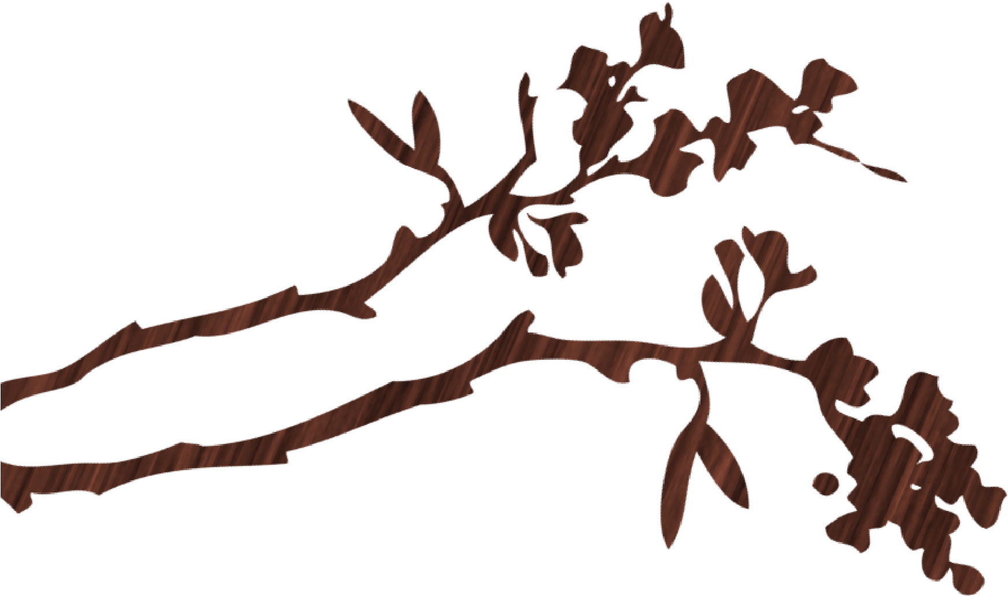

CHINESE LANGUAGE &

CULTURE CLUB

中文

&

文化俱乐部

**Chinese Language & Culture Club (CLCC)** - The goal of this organization is to connect students studying中文, regardless of level, to meet on and off campus in a casual/relaxed environment to practice/improve our speaking skills.

This club communicates via GroupMe. If interested please shoot us an email and we will be sure to add you to the group!

CLCC Position Holders:

:

President: Chance Chambers

Treasurer: Carter Bishop

Vice President: Blake Farris

Director of Membership: Zachary Tipton

Secretary: Rose Schneider

Director of Recruitment: Taylor Smith